# Simio API Note: Interfacing with GIS Data

**Document History**

Creation: 15 Feb 2018

Revisions: 14 Mar 2018 – Including extra DLL instructions.

Revisions: 01 Aug 2019 – Fixed and enhanced Scaling login

Contents

Simio API Note: Interfacing with GIS Data 1

Overview 2

Installing the GIS Add-In 6

Modifying/Developing the Add-In 6

GIS – Getting the Data from the Web 9

Data Provider Examples 10

GIS Service Provider: Microsoft’s Bing Maps (VirtualEarth) 12

Response Information Detail 13

Bing Maps Key 15

The Simio Side 16

A Note on Coordinates 16

Appendix – References 17

Bing Maps (VirtualEarth) References 17

BingMapsRESTToolkit Samples 19

# Overview

GIS (Geographic Information System) data can be an important source of data for Simio models. However, the collection and loading of this data into a simulation can be cumbersome.

This GisAddIn Simio Add-In was constructed to demonstrate how Simio can be extended to work with 3rd party GIS APIs (Application Programming Interfaces) to automatically construct Simio models.

This Simio Add-In interface provides a demonstration of this GIS-to-Simio capability. It can be used to automatically construct simulation paths from routes obtained via a GIS service.

After being launched by Simio, the GisAddIn does this by:

1. Prompting a user for two locations: From and To.
2. Getting GIS information to provide a set of highway directions (a route) using a web-based GIS API.
3. Using GIS-obtained route to construct Simio objects. Specifically, paths between a ‘from’ and ‘to’ node.

It is constructed as an Simio “Add-In”, which by convention means that it is a DLL that is called by Simio desktop application while in the Simulation Design mode of Simio.

The Add-In is launched from the “Project Home” ribbon by selecting from the “Select Add-In” button, and then choosing GIS Interface.

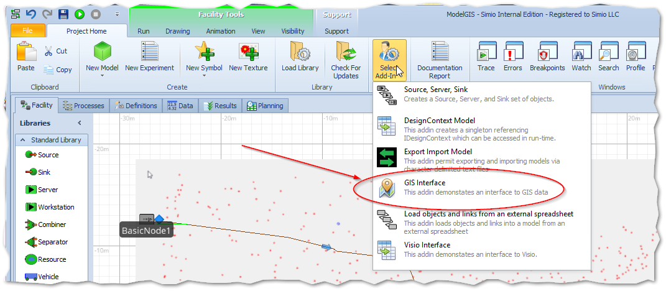

Once launched, the Add-In brings up its UI, which is a WinForms ‘test’ screen that allows you to enter the “From” and “To” points and then press a button to request a route from the GIS API. When the GisAddIn form is closed, the construction of the Simio objects takes place.

On the Bing Maps tab are found boxes to enter a “From” and “To”. GIS providers today are very flexible with what you can enter here. For example, you could enter street addresses and a zip code, or just a city with a state (in which case the GIS provider chooses a default location), or even simply a zip code.

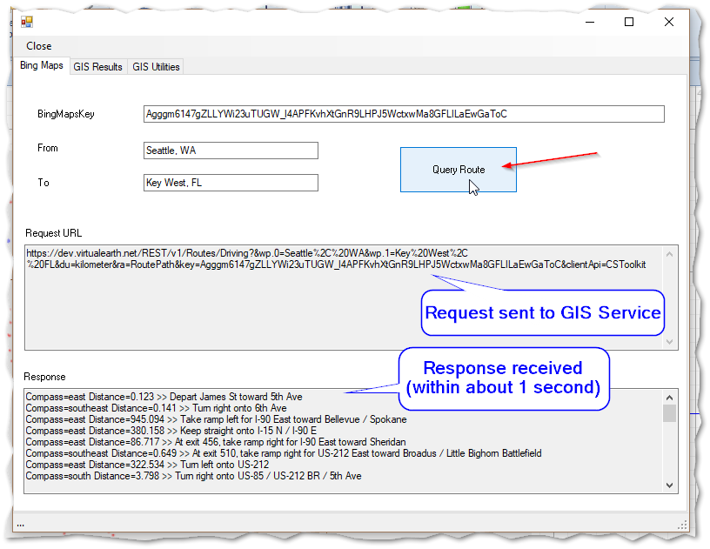

Figure - The GisAddIn User Interface

Once the “From” and “To” are chosen, press the button and the GisAddIn will construct a “Route’ request query and send it to the GIS Provider. When you are satisfied with your route, close the form and the Add-In will construct the Simio objects in the proper location on the Simio Facility view.

The Simio objects are constructed comprising two “BasicNode” nodes with a Path between them. These nodes are attached to a Simio Source and Sink so that the model is immediately available to run.

Note that for this Add-In, the dimensions were chosen so that a unit of latitude and longitude each correspond to a meter in Simio’s Facility coordinate system. The convention for this demonstration uses a bounding box that is from 20 to 50 North latitude and -60 to -130 longitude, with the lat/lon mid points of -95, 35 being centered at the Simo origin (0,0).

GisAddIn can be invoked repeatedly to add more routes to the model.

Here is a screenshot of a Simio Facility view with three routes added to a Model, and the model running (note the green triangle Entities). Note that the pointillism ‘map’ is simply an imported symbol showing cities within the contiguous US.

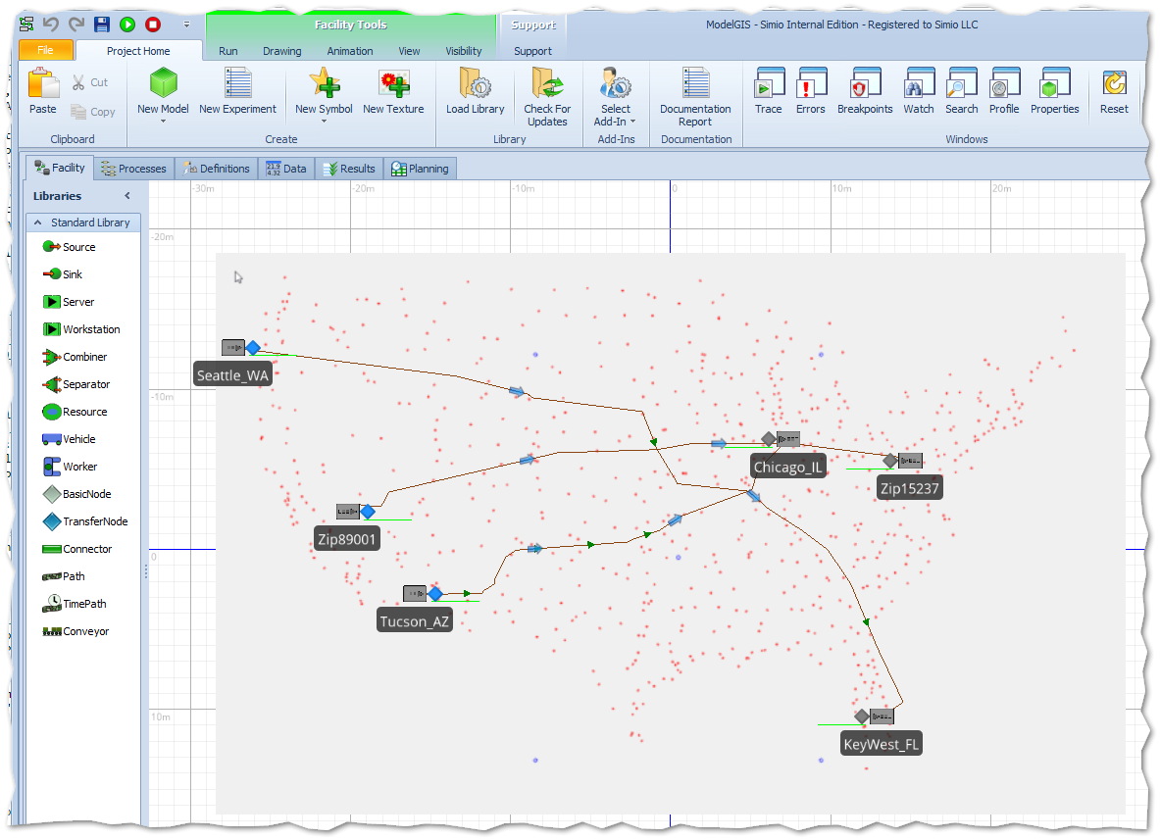

Scaling the Results

A tab name Simio Display Info exists to illustrate how the results can be scaled.

The top four boxes allow you to create a bounding box for your entire lat/lon display area. In the example above we are intending to add multiple routes within the USA and so have chosen a box the pretty much encompasses the entire mainland USA. This box will be centered at the origin.

The bottom two boxes show how we want to scale longitude and latitude to the meters on the Simio Facility View.

# Installing the GIS Add-In

The GIS Add-In is distributed to the Forum as a zip file, which – besides this documentation - includes:

1. GisAddIn.dll
2. BingMapsRESTToolkit.dll
3. Mathnet.Numerics.dll
4. ModelGIS.spfx

The first three are DLL files that should be placed in a directory together in a standard location so that Simio can find them and place the Add-In in the toolbar when it runs:

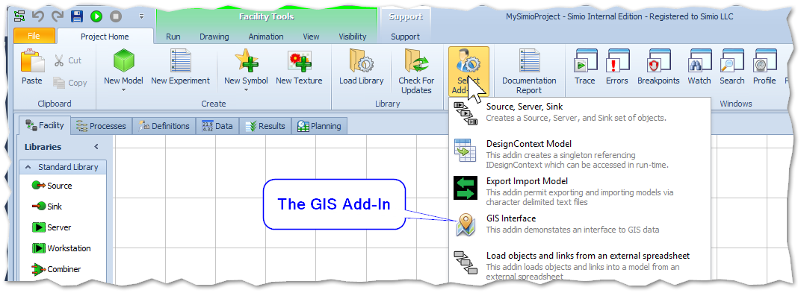

One such standard location is under {your-user}\documents\SimioUserExtensions. Place all the DLL files in this folder.

The “.spfx” file is the Simio model, and can be placed wherever you wish. A standard location is

{your-user}\documents\SimioModels

## Modifying/Developing the Add-In

If you are modifying the Add-In (for example, in Visual Studio) you should get the additional files (the GIS Map SDKs and numeric library using NuGet). This is done by going to Tools > NuGet Package Manager > Manage NuGet Packages for Solution…

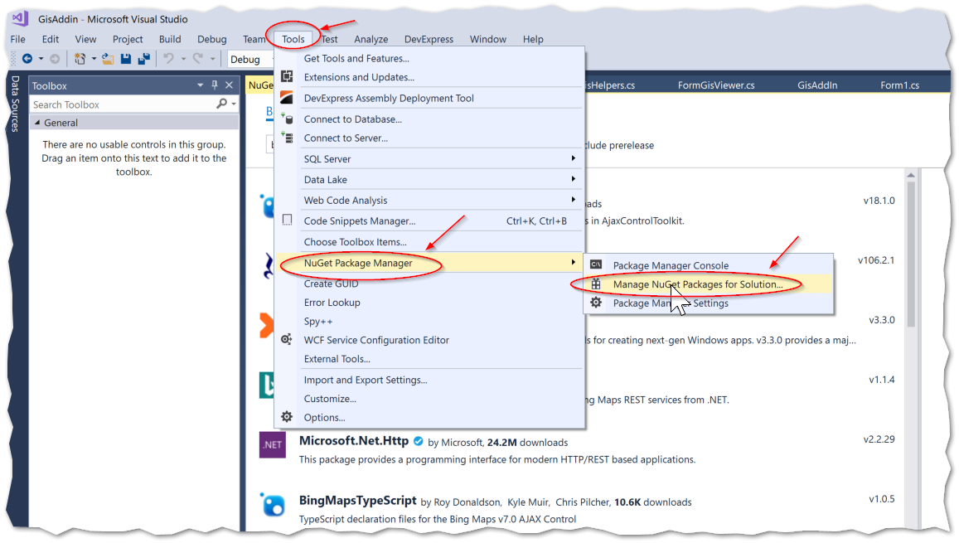

And then browsing for the packages as shown. Using NuGet (as opposed to copying DLLs) ensures that you get the most recent versions.

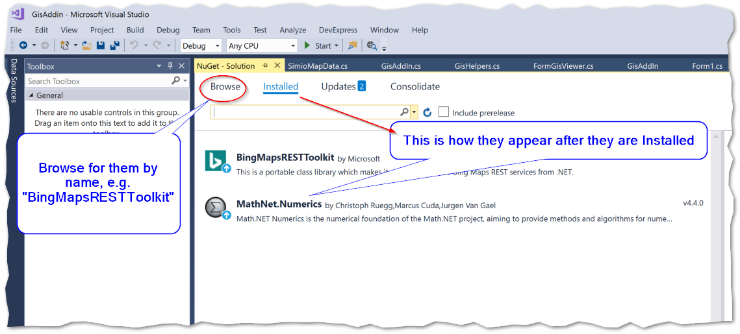

# GIS – Getting the Data from the Web

GIS data used in the GisAddIn is gathered from the web with what is called a REST-compliant service on the internet. The REST (REpresentational State Transfer). What this means is that the calling techniques – regardless of the GIS Service Provider used - will likely be consistent.

How the data is returned will most likely be XML or JSON, but the organization of the data will vary widely depending on the provider. Each provider will likely have their own ‘kit’ or SDK (Software Development Kit) to provide us with the tools to easily implement the communications. But, it will always end up being a Request to the service, following (within a few seconds) by a Response with our data.

Each Provider will require a “key” to make requests of their system. This is because they must maintain an expensive infrastructure to supply this information, and because they wish accountability of the users of their system. Often this key will be free if your volume of requests is below a given threshold.

For example, Microsoft, via Bing Maps and their Virtual Earth service, a REST-full API (Application Programming Interface). A ‘free’ key available, so long as you stay below a certain data transaction level.

These are the same services that power most smart-phone, desktop, and web applications, but in developing this Add-In we are going to use the services directly.

In fact, you can copy the contents of the Add-In’s “Request URL” textbox (place your cursor in the Add-In’s Request URL box) and then:

1. CTRL-A to select all,
2. CTRL-C to cut, and then
3. go to your browser’s URL and CTRL-V to paste.

Then hit the ENTER and you’ll see the results:

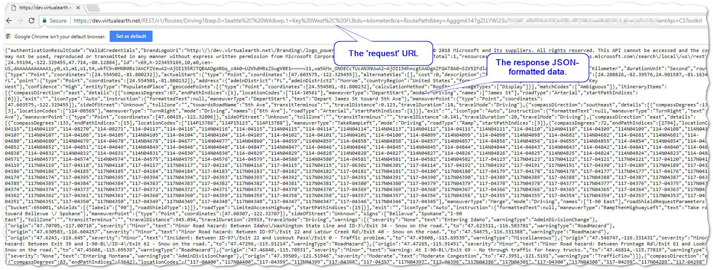

The GIS data that can be received from these providers is not simply routing. Each provider has a large and rapidly growing set of features.

For example, Bing Maps can supply routes for Trucks, where the characteristics of the truck (e.g. weight) are taken into consideration.

Other Responses include distance matrices and even solutions to the Travelling Salesman problem.

# Data Provider Examples

This section shows examples of data providers and the Add-In is used to process the data. The first API (Feb 2018) is Bing Maps, with the intent that more will be added as they are encountered.

Most of the GIS APIs work basically in the same fashion, as illustrated by the diagram below:

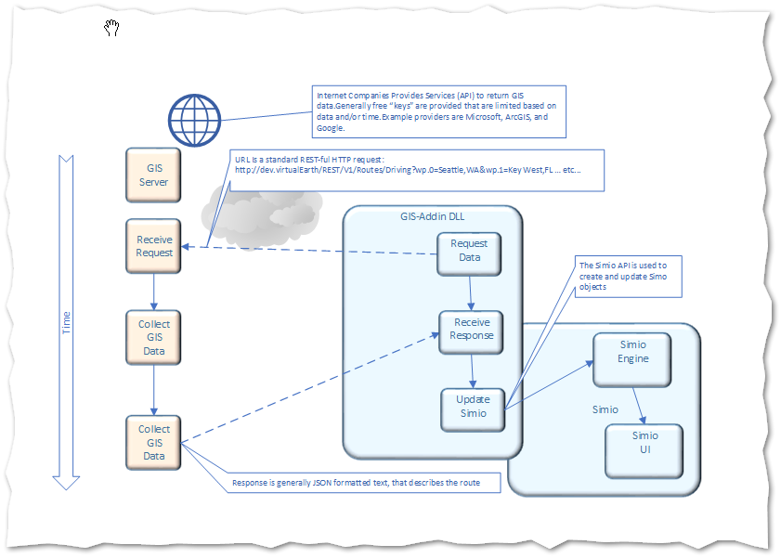

## GIS Service Provider: Microsoft’s Bing Maps (VirtualEarth)

Bing Maps provides a GIS data service for getting information.

For example, the following URL:

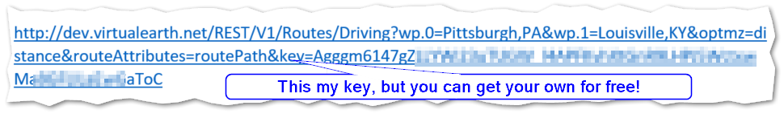

Will return Response GIS data in JSON format:

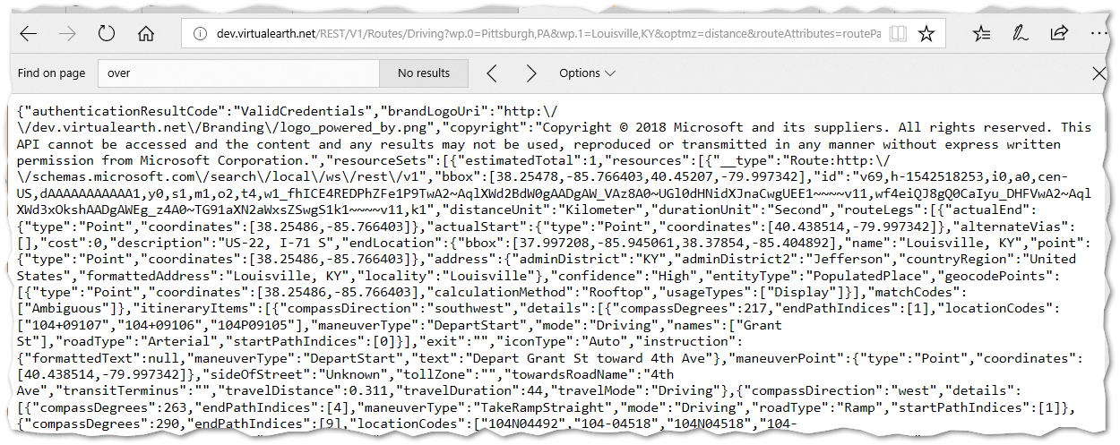

Figure - A Portion of the Response Data in Unformatted JSON

Which can be viewed in Notepad++ with the JSON Viewer plugin:

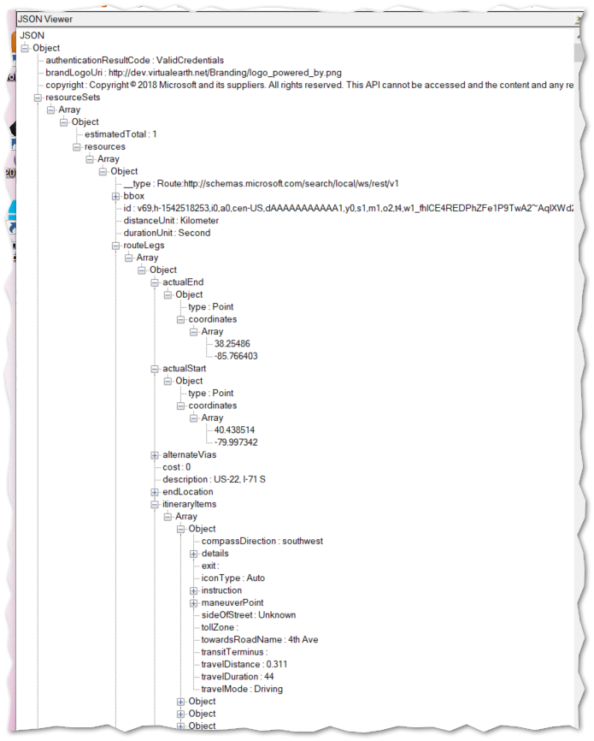

### Response Information Detail

The response information contains all the information about all the paths from here to there. And it is a lot of data and can be controlled by a myriad of options. Refer to the Appendix for more detailed information on this interface.

The add-in processes this information, simplifies it according to the user’s wishes, and then creates Simio nodes and links from the data.

From the Tree outline from Notepad++, you can see that file contains:

1. A bounding box, in lat/lon coordinates
2. An array of routeLegs
3. An array of routePaths

The routePath is an array of coordinates. Each adjoining coordinates (lat,lon) are referenced (by index) by a RouteLeg itineraryItems, which are essentially driving instructions.

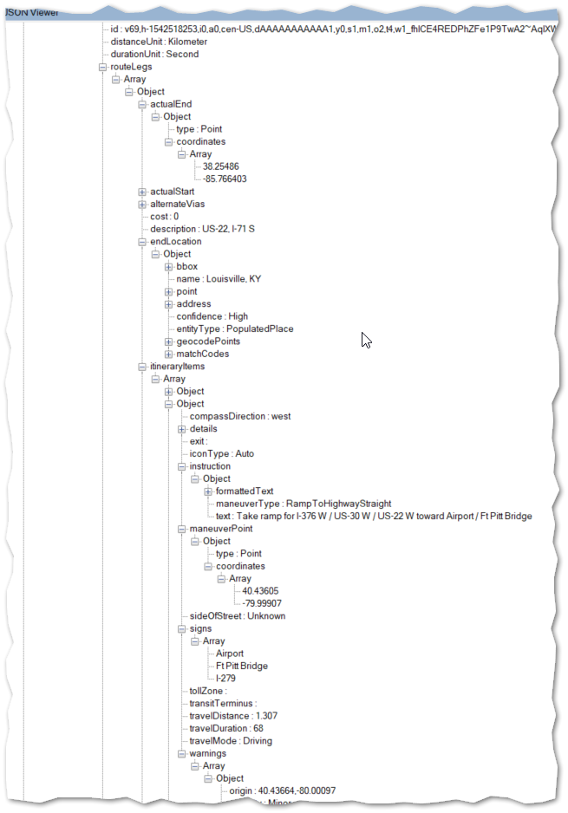

Figure - Response Data Shown in a Tree Structure

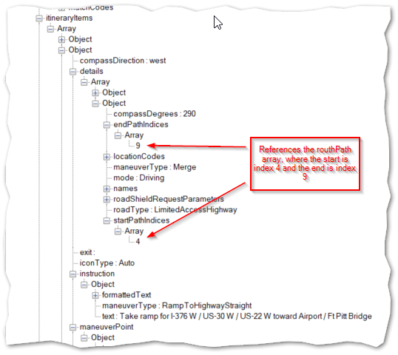

Figure - Response Data Showing Itinerary Details

Data Processing

To help with the processing, the GisAddIn employs the BingMapsRESTToolkit package. This package can be located and installed in Visual Studio by invoking Tools > NuGetPackageManager .

PM>Install-Package BingMapsRESTToolkit

### Bing Maps Key

This link:

<https://msdn.microsoft.com/en-us/library/ff428642.aspx>

explains the rules and the procedures for getting a Bing Maps Key.

# The Simio Side

Now lets talk about the Simio side of this equation. From the docs, we have these objects:

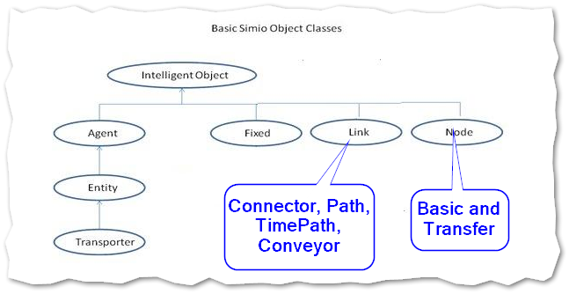

For this demonstration we are going to create two Basic Nodes (at the beginning and end), and we’ll use the Path to connect them.

For this example, the Path Link was used. However, you should consider the TimePath as well, as it provides a way to set the time for the entire route. (This time was included in the Bing Maps response data).

Because each GIS Provider is going to have a different format for the response, a canonical set of data classes is provided in the GisAddIn, and it is these classes that the methods that build the Simio objects from. These can be found in the SimioMapData.cs file.

Methods within the GisHelpers.cs file include helper methods for serializing and deserializing JSON data. There is also a method used to convert lat/lon data to Simio’s Facility coordinates.

### A Note on Coordinates

Note that by convention we say lat-lon instead of the reverse, however usually the longitude is thought of as the “x” axis. Also remember that Simio is a 3D visualization model. As such, we are generally “looking down” on the X-Z coordinate space, where Z becomes more negative as it goes away from us. So generally we are translating lat/lon to an (X,Y,Z) of something like (LON, 0, -LAT).

# Appendix – References

## Bing Maps (VirtualEarth) References

Using the REST Services with .NET

<https://msdn.microsoft.com/en-us/library/jj819168.aspx>

Microsoft has produced an Open Source project that incorporates ‘best practices’ for using their API and maintains it on GitHub as BingMapsRESTToolkit.

<https://github.com/Microsoft/BingMapsRESTToolkit/>

Here is a sample of the documentation; the The RouteRequest Class:

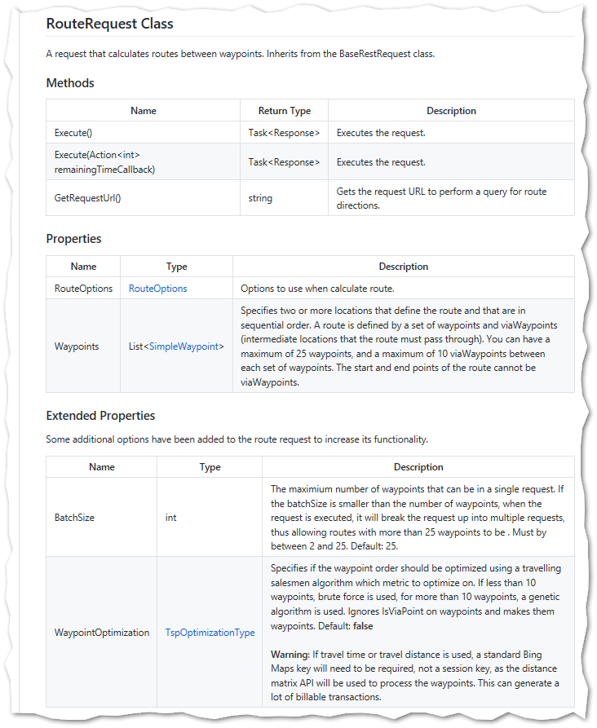

### BingMapsRESTToolkit Samples

There are two sample projects provided; Console and WPF. The WPF is much more full-featured than the console, and is probably your best choice for seeing how the Toolkit operates and for grabbing pieces of code.

#### WPF Example Screen

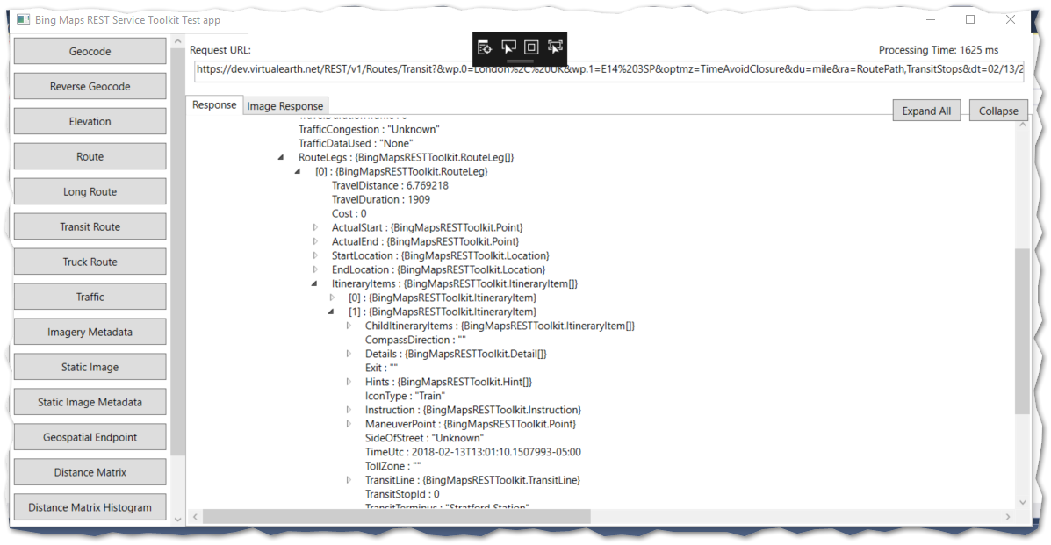

Note that there are Long, Transit, and Truck routes as well as plain Route.

Here is a sample of the “Route” Code, showing how to employ Route options:

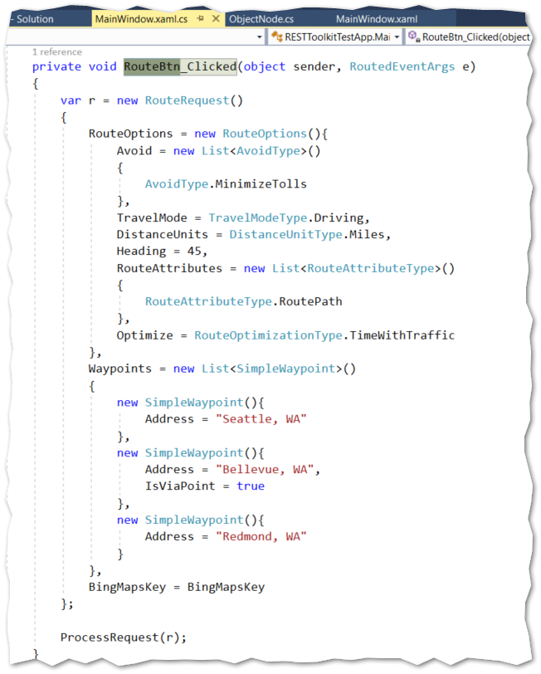

And also some code for handling the ProcessRequest. Note that the method is an “Async” method, and uses the “await” keyword to keep your code from stopping other threads - like the UI – in your application.

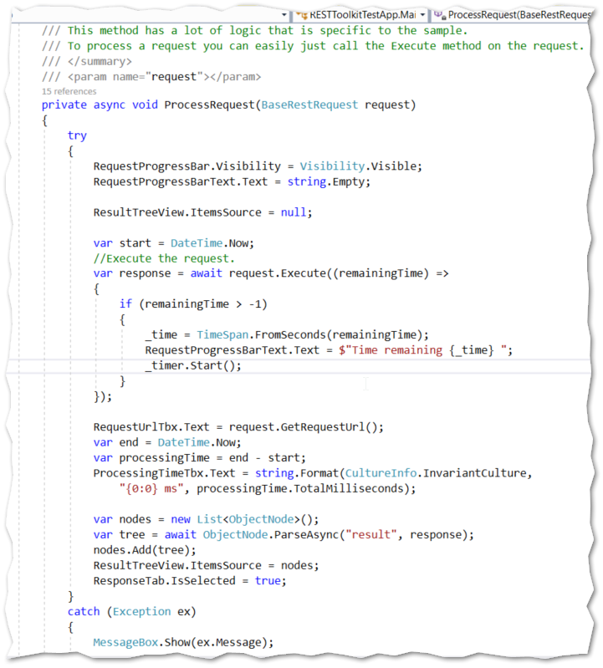

Appendix – References

USGS

<https://www.usgs.gov>

Bing Maps REST Services

<https://msdn.microsoft.com/en-us/library/ff701713.aspx>

BingMapsRESTToolkit (Preferred interface, according to Microsoft)

<https://github.com/Microsoft/BingMapsRESTToolkit/>

Google Web Services > Directions API

<https://google-developers.appspot.com/maps/documentation/directions/>